Carry park

baseURL: http://159.65.150.119/

User Registration API
This is a called from Carry Park app, to register a user account.

URL: {{baseURL}}/api/maintenance/userRegister

Method: POST

Header:
Not Required

Body:

Required:
first_name=[ alphanumeric]
email=[ alphanumeric]
dob=[ alphanumeric]
mobile=[ alphanumeric]
phone_code=[ integer]
mac_id=[ alphanumeric]
country=[ alphanumeric]

Required:
lang_id=[ alphanumeric]

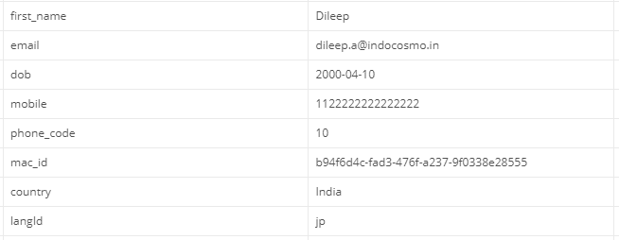

Output :

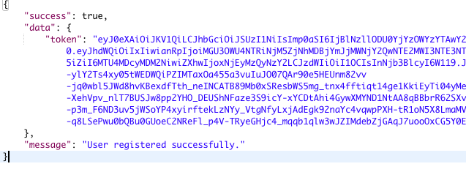

User Login API
This is a called from Carry Park app, to log into a user account.

URL: {{baseURL}}/api /userLogin

Method: POST

Header:
Not Required

Body:

Required:
email=[ alphanumeric]
dob=[ alphanumeric]
pin=[ integer]
mac_id=[ alphanumeric]
client_id=[ alphanumeric]
client_secret=[ alphanumeric]

Required:
lang_id=[ alphanumeric]

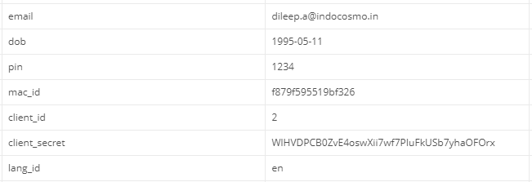

Output :

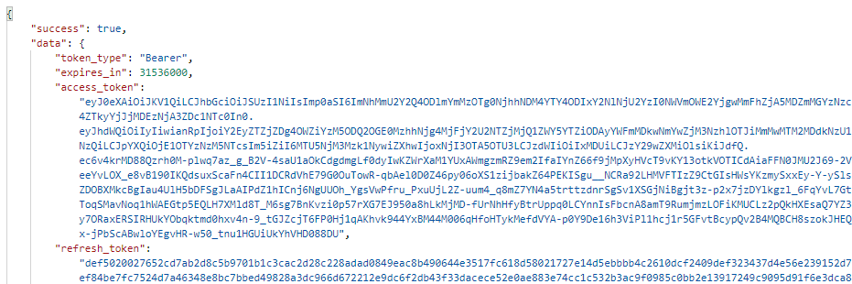

User Login using OTP
This is a called from Carry Park app, to log into a user account using OTP.

URL: {{baseURL}}/api /userOTPlogin

Method: POST

Header:
Not Required

Body:

Required:
pin=[ integer]
mac_id=[ alphanumeric]
client_id=[ alphanumeric]
client_secret=[ alphanumeric]

Required:
lang_id=[ alphanumeric]

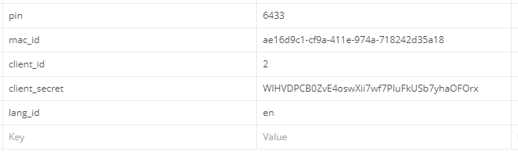

Output :

Resend PIN
This is a call from the Carry Park app to resend the PIN.

URL: {{baseURL}}/api /resendPin

Method: POST

Header:
Required:
Authorization=[ alphanumeric]
Optional:
Content-Type=[alphanumeric]
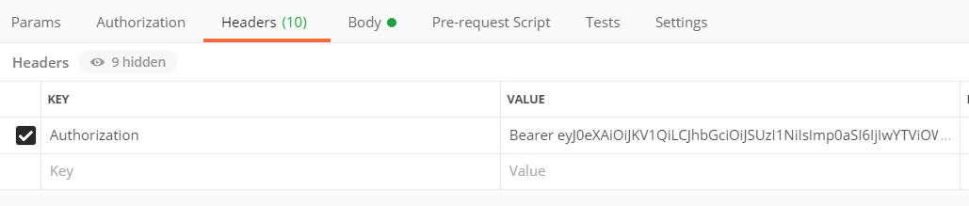

Body:

Required:
email=[alphanumeric]
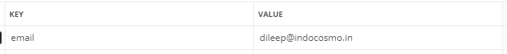

Output :

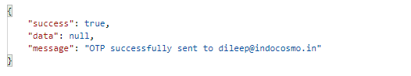

Get Locker Details
This is a call from the Carry Park app to get the locker details.

URL: {{baseURL}}/api /locker/show

Method: POST

Header:
Required:
Authorization=[ alphanumeric]
Optional:
Content-Type=[alphanumeric]

Body:

Required:
device_id=[alphanumeric]
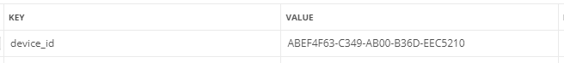

Output :

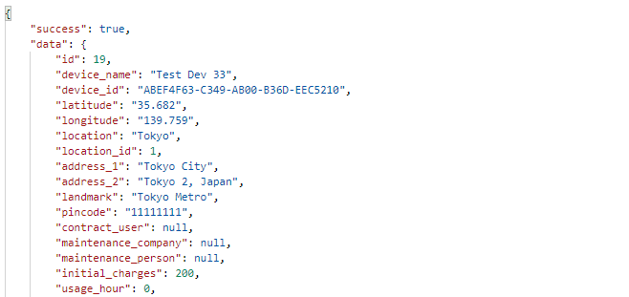

Finding nearest devices
This is a called from mobile app, to get list of nearby devices.

URL: {{baseURL}}/api/nearestDevices

Method: POST

Header:
Required:
Authorization=[ alphanumeric]
Optional:
Content-Type=[alphanumeric]

Body:

Required:
latitude=[ alphanumeric]
longitude=[ alphanumeric]

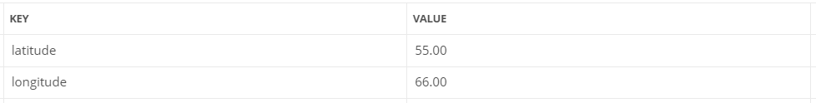

Output :

Success Response(List of all nearby devices):
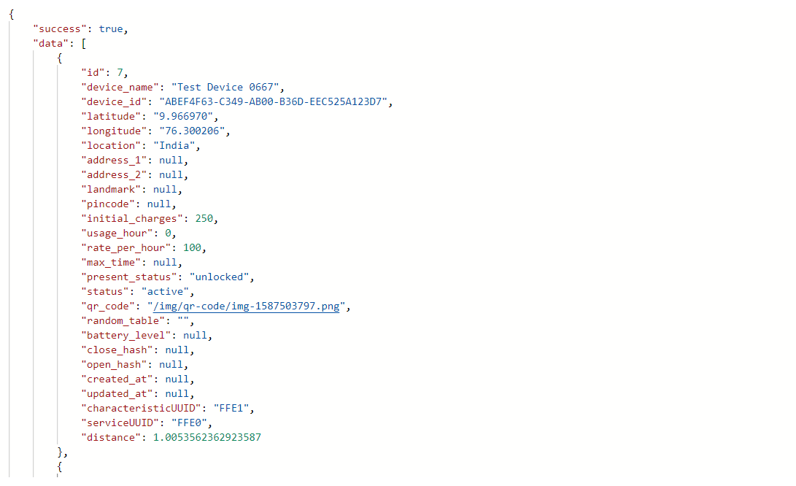

Log errors
This is a called from mobile app, to log errors from devices in database.

URL: {{baseURL}}/api/logError

Method: POST

Header:
Required:
Authorization=[ alphanumeric]
Optional:
Content-Type=[alphanumeric]

Body:

Required:
device_id=[ alphanumeric]
error_code=[ alphanumeric]

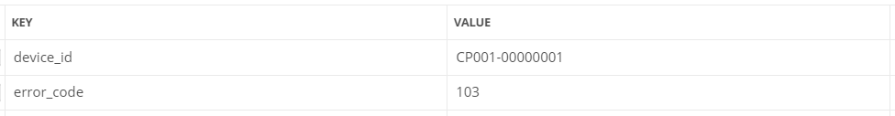

Output :

Success Response:
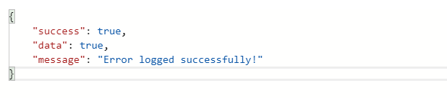

Error Response:

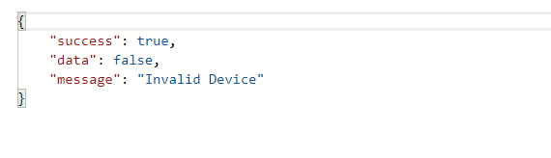

Errors list
This is a called from mobile app, to get the list of all errors.

URL: {{baseURL}}/api/errors

Method: GET

Header:
Required:
Authorization=[ alphanumeric]
Optional:
Content-Type=[alphanumeric]

Output :

Success Response:
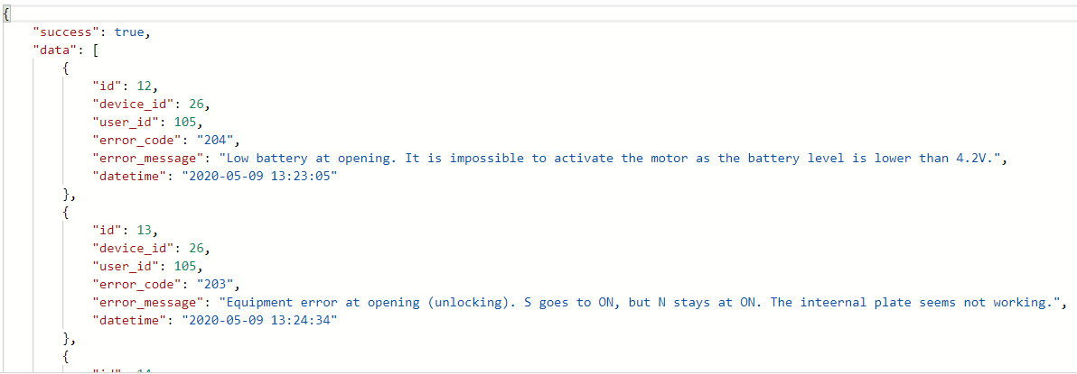

Get Payment URL
This is a call from the Carry Park app to get the Takeme Pay payment URL.

URL: {{baseURL}}/api/universal_payment

Method: POST

Header:
Required:
Authorization=[ alphanumeric]
Optional:
Content-Type=[alphanumeric]

Body:

Required:
device_id=[alphanumeric]

Output :

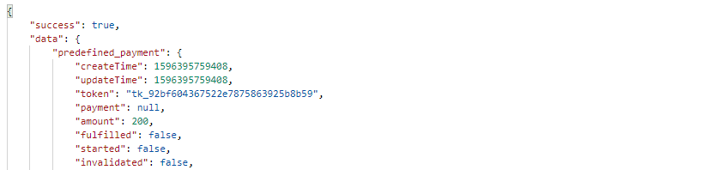
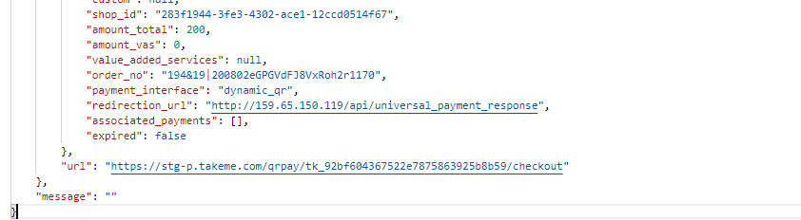

Check Payment status
This is a call from the Carry Park app to check the status payment.

URL: {{baseURL}}/api/check_payment_status

Method: POST

Header:
Required:
Authorization=[ alphanumeric]
Optional:
Content-Type=[alphanumeric]

Body:

Required:
token=[alphanumeric]
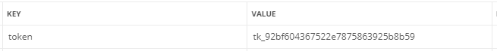

Output :

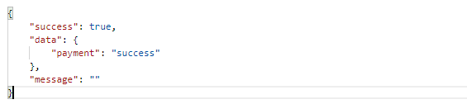

Locker Lock/Unlock API
This is a call from the Carry Park app to lock/unlock locker device.

URL: {{baseURL}}/api/success

Method: POST

Header:
Required:
Authorization=[ alphanumeric]
Optional:
Content-Type=[alphanumeric]

Body:

Required:
device_id=[alphanumeric]

Compose Hash Key for Security
This is a call from the Carry Park app to create a hash key for security purpose.

URL: {{baseURL}}/api/composeHashMsg

Method: POST

Header:
Required:
Authorization=[ alphanumeric]
Optional:
Content-Type=[alphanumeric]

Body:

Required:
device_id=[alphanumeric]
command_text=[alphanumeric]
random_app_key=[alphanumeric]
starting_position=[integer]
key_string_length=[integer]
skip_chars=[integer]

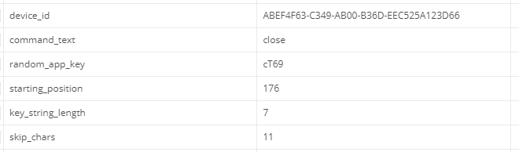

Output :

